Domain Analysis

* Pen and paper part (planning part of the program)

Go to design recipe: <https://courses.edx.org/courses/course-v1:UBCx+HtC1x+2T2017/77860a93562d40bda45e452ea064998b/>

-> How to Design Worlds (HtDW)

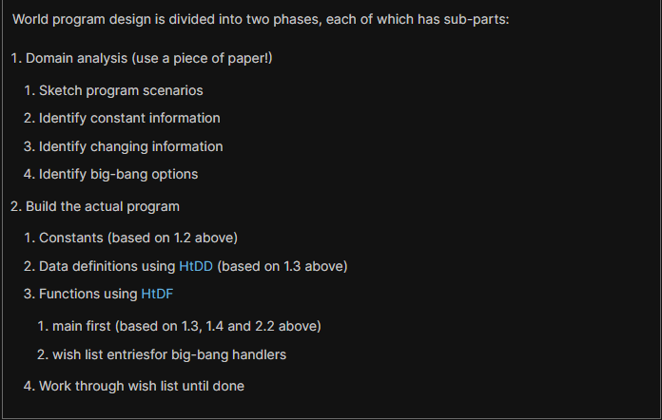

* We’ll do domain analysis for this part

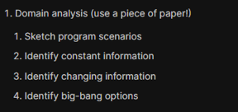

1. Sketch program scenarios

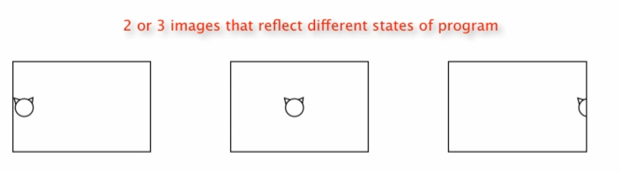

* + Try to catch interesting events
    - Sometimes you need more than 3 images

1. Identify constant information

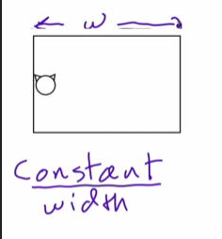 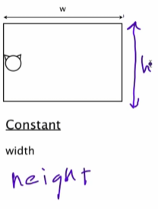 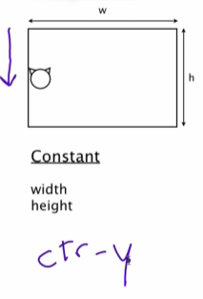

Note: (0,0) is the UPPER LEFT of the screen or background scene and y-values increase by going DOWN

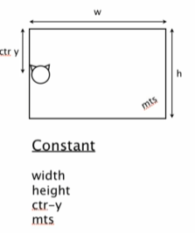 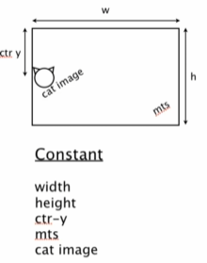

Note: it’s perfectly fine to go back and revise the domain analysis later if you discover something you didn’t think before

1. Identify changing information

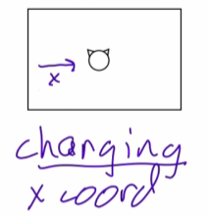

1. Identify big-bang options

Go to recipe page -> scroll down a bit on HtDW

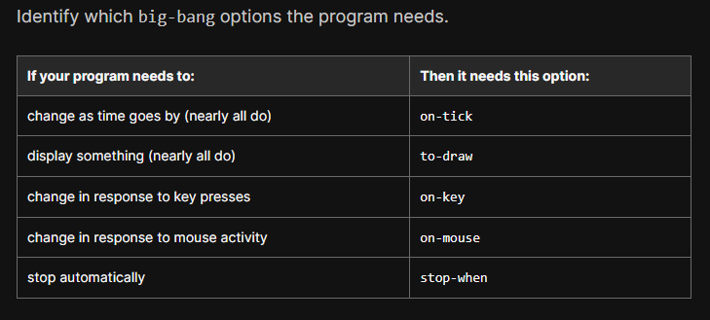

We’ll need these options for this program:

* + on-tick
  + to-draw

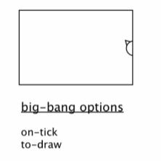

Final overview of our domain analysis

